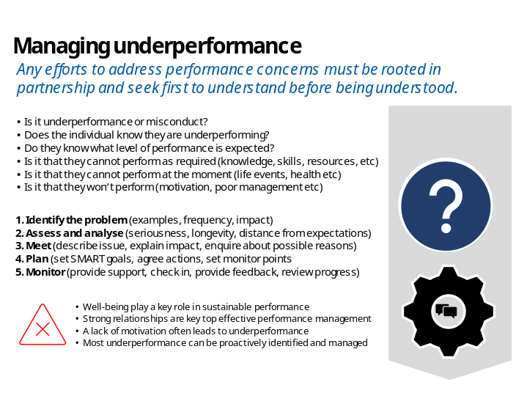 | 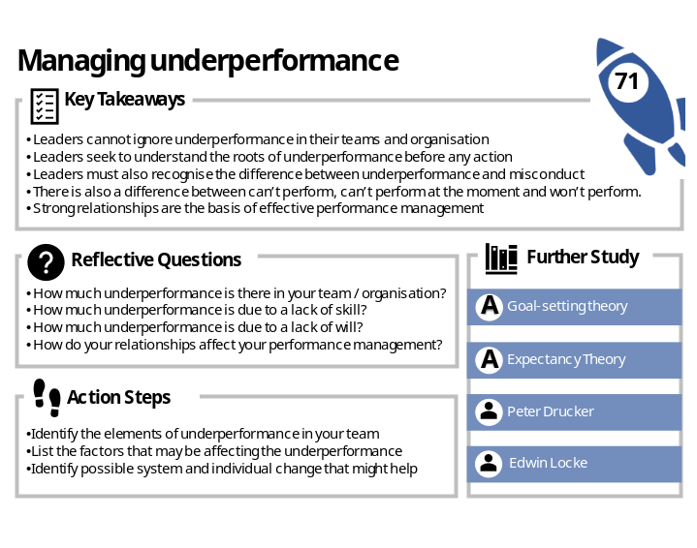

Leadership Launchpads – Ignition Sheet
Use the following question funnel to drive further reflection, insight and action
 | WHAT? | - What resonated most with you?  - What challenged your thinking the most? | - What was your biggest takeaway?  - What are you still unsure about?

 | SO WHAT? | - Why did it resonate with you?  - Why did it challenge you? | - Why is this topic important in your role?  - Why do others need to know about it?

 | NOW WHAT? | - How has it changed your thinking?  - How will it change your behaviour? | - How will you take the first step?  - How will you know it has had an impact?

